
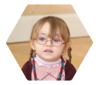

My Early Years Passport

Add any photos or other information that
you would like to see in this section

Introducing ourselves

Place a photo here
if you wish

Child’s name: .……………………………………………….

Date of birth: .……………………………………………….

NHS number: ….…………………………………………….

Family contact address: …….…………………………………………..

…………………………………………………

…………………………………………………

…………………………………………………

Parent or carer names: …………………………………………………

Telephone number: …………………………………………………

Mobile ………………………. Email ……………………………..

My Early Years Passport

Add any photos or other information that
you would like to see in this section

Introducing ourselves (2)

Child’s position in the family ……………..……………………….

The language we use at home is; ……………..……………………….

Our cultural background / religion is ....…………………………………

We will require language interpretation support YES …. NO….

My child attends these other childcare settings ….…………………….

….…………………………………..

.………………………………………

The school we think our child will attend is: …..…………………………

Other things we would like you to know about our family
…………………………………..….…………………………………………
..........................................................……………………………………..

…………………………………………………………………………………

…………………………………………………………………………………

…………………………………………………………………………………

…………………………………………………………………………………

My Early Years Passport

Add any photos or other information that
you would like to see in this section

These are some of the important
people in ……………’s life
…………………………………..….…………………………………………
..........................................................……………………………………..

…………………………………………………………………………………

…………………………………………………………………………………

…………………………………………………………………………………

…………………………………………………………………………………

………………………………………………………………………………….

…………………………………..….…………………………………………
..........................................................……………………………………..

…………………………………………………………………………………

…………………………………………………………………………………

…………………………………………………………………………………

…………………………………………………………………………………

………………………………………………………………………………….

………………………………………………………………………………….

………………………………………………………………………………..

My Early Years Passport

Add any photos or other information that
you would like to see in this section

Things we would like you to
know about our child …….
…………………………………..….…………………………………………
..........................................................……………………………………..

…………………………………………………………………………………

…………………………………………………………………………………

…………………………………………………………………………………

…………………………………………………………………………………

………………………………………………………………………………….

…………………………………..….…………………………………………
..........................................................……………………………………..

…………………………………………………………………………………

…………………………………………………………………………………

…………………………………………………………………………………

…………………………………………………………………………………

………………………………………………………………………………….

………………………………………………………………………………….

………………………………………………………………………………..
My Early Years Passport

Add any photos or other information that
you would like to see in this section

Medication, allergies and
Food-intolerance information

…………………………………..….…………………………………………
..........................................................……………………………………..

…………………………………………………………………………………

…………………………………………………………………………………

…………………………………………………………………………………

…………………………………………………………………………………

.
Details in case of emergency

Our family doctor is; .......................……………………………………..

Address: ………………..………..……………………………

………………………………………………………

Telephone number: ………………………………………………………

Emergency contact ……………………………………………………..

…………………………………………………….. .

Emergency contact ……………………………………………………..

………………………………………………………

My Early Years Passport

Add any photos or other information that
you would like to see in this section

Things …………… likes

……………………………..….…………………………………………
..........................................................……………………………………..

…………………………………………………………………………………

…………………………………………………………………………………

…………………………………………………………………………………

…………………………………………………………………………………

………………………………………………………………………………….

Things …………… doesn’t like

……………………………..….…………………………………………
..........................................................……………………………………..

…………………………………………………………………………………

…………………………………………………………………………………

…………………………………………………………………………………

…………………………………………………………………………………

…………………………………………………………………………………

My Early Years Passport

Add any photos or other information that
you would like to see in this section

Here is a list of people working
with our family

Name: .……………………………………………….

Professional role: .……………………………………………….

Address: ….…………………………………………….

Telephone or mobile: …….…………………………………………..

Nature of contact: ……………………………………………………..

Name: .……………………………………………….

Professional role: .……………………………………………….

Address: ….…………………………………………….

Telephone or mobile: …….…………………………………………..

Nature of contact: ……………………………………………………..

Name: .……………………………………………….

Professional role: .……………………………………………….

Address: ….…………………………………………….

Telephone or mobile: …….…………………………………………..

Nature of contact: ……………………………………………………..

My Early Years Passport

Add any photos or other information that
you would like to see in this section

These are the best times for
us to meet with you to talk
about our child
…………………………………..….…………………………………………
..........................................................……………………………………..

…………………………………………………………………………………

…………………………………………………………………………………

Here are our other preferred
ways of keeping in touch


telephone mobile email home visits

The best times for our family are

Telephone: ………………….....……………………………………..

Mobile phone: ………………. ………..…………………………………
. . Email: …………………………………………...………………..

Home visits: …………………………..…………………………………
My Early Years Passport

Add any photos or other information that
you would like to see in this section

These are the things people
have been noticing about
my learning journey so far…

………………………..….…………………………………………
..........................................................……………………………………..

…………………………………………………………………………………

…………………………………………………………………………………

…………………………………………………………………………………

…………………………………………………………………………………

………………………………………………………………………………….

…………………………………..….…………………………………………
..........................................................……………………………………..

…………………………………………………………………………………

…………………………………………………………………………………

…………………………………………………………………………………

…………………………………………………………………………………

………………………………………………………………………………….

………………………………………………………………………………….
My Early Years Passport

Add any photos or other information that
you would like to see in this section

Here is a plan of my
child’s week

Date: | Morning | Afternoon
Monday

Tuesday

Wednesday

Thursday

Friday

Date: | Morning | Afternoon
Monday

Tuesday

Wednesday

Thursday

Friday

My Early Years Passport

Add any photos or other information that
you would like to see in this section

My child’s weekly plan
(continued)

Date: | Morning | Afternoon
Monday

Tuesday

Wednesday

Thursday

Friday

Date: | Morning | Afternoon
Monday

Tuesday

Wednesday

Thursday

Friday

My Early Years Passport

Add any photos or other information that
you would like to see in this section

Meeting my child’s needs
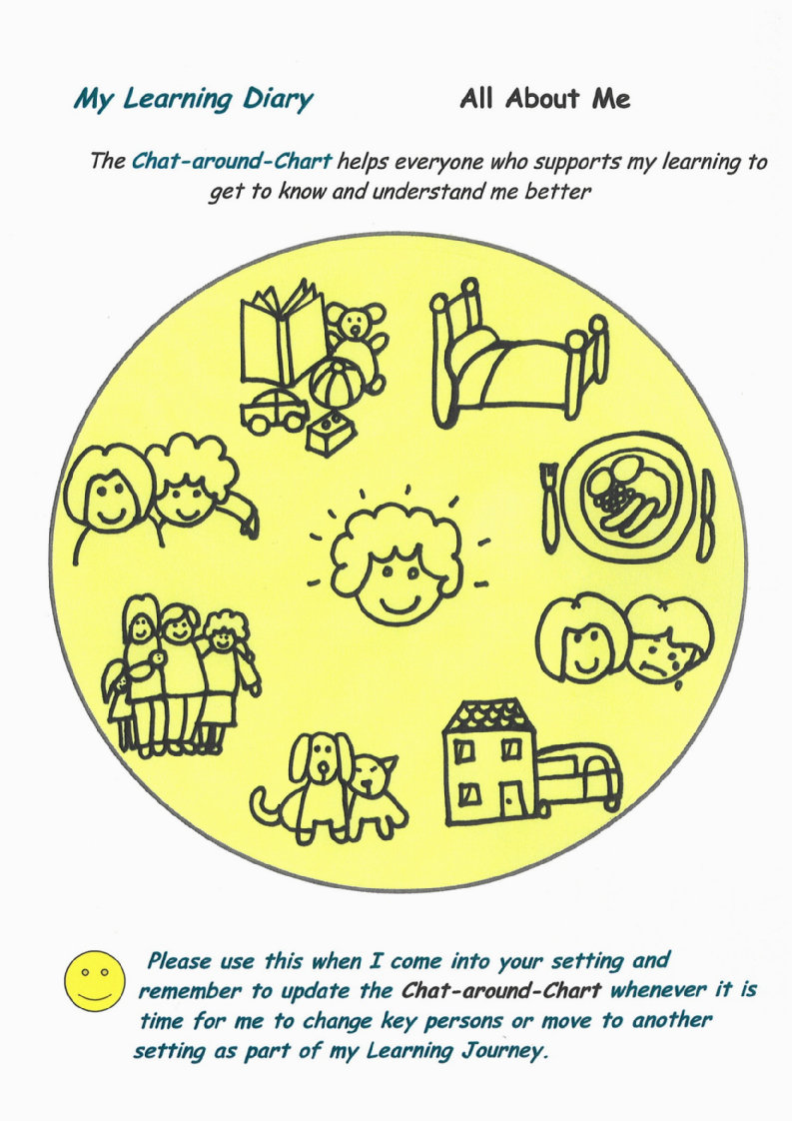

My Early Years Passport

Add any photos or other information that
you would like to see in this section

Meeting my child’s needs
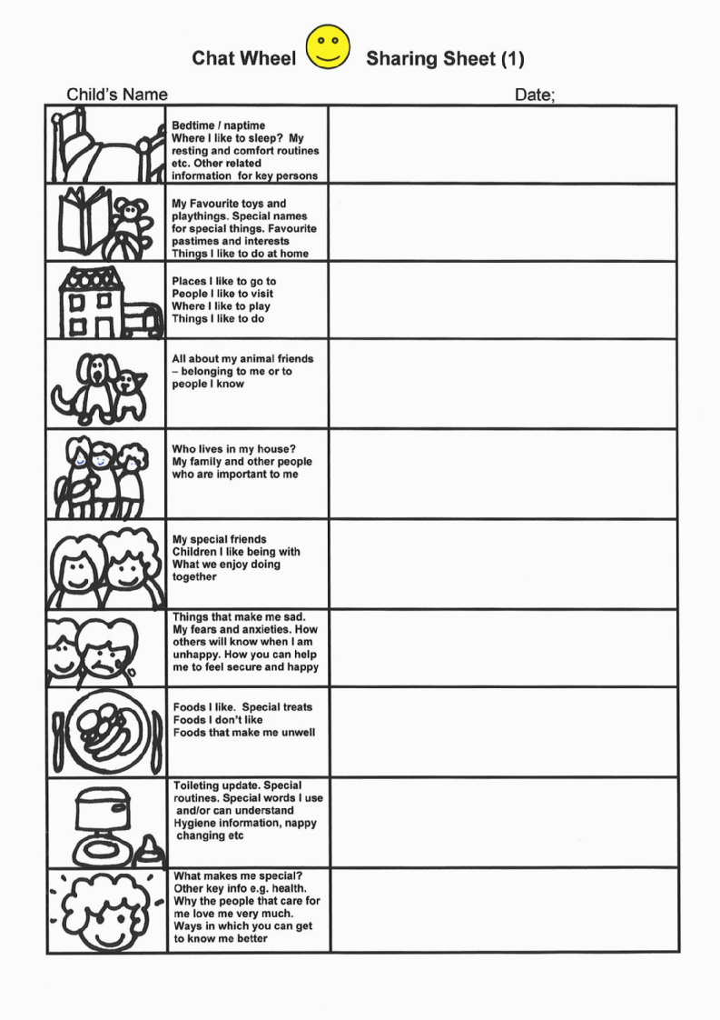

My Early Years Passport

Add any photos or other information that
you would like to see in this section

Places I have been
on my Learning Journey

Name of EYFS provider
Address;

Day Nursery |  | Pre-school /  playgroup |  |  | Childminder |  | Nursery class / school
My session starts at |  |  |  |  | My session finishes at
Monday | Tuesday |  |  | Wednesday |  | Thursday |  | Friday
Date I started; |  |  |  |  | Date I transferred;
I am moving to a new / further setting because;

Name of EYFS provider
Address;

Day Nursery |  | Pre-school /  playgroup |  |  | Childminder |  | Nursery class / school
My session starts at |  |  |  |  | My session finishes at
Monday | Tuesday |  |  | Wednesday |  | Thursday |  | Friday
Date I started; |  |  |  |  | Date I transferred;
I am moving to a new / further setting because;

My Early Years Passport

Add any photos or other information that
you would like to see in this section

Places I have been
on my Learning Journey

Name of EYFS provider
Address;

Day Nursery |  | Pre-school /  playgroup |  |  | Childminder |  | Nursery class / school
My session starts at |  |  |  |  | My session finishes at
Monday | Tuesday |  |  | Wednesday |  | Thursday |  | Friday
Date I started; |  |  |  |  | Date I transferred;
I am moving to a new / further setting because;

Name of EYFS provider
Address;

Day Nursery |  | Pre-school /  playgroup |  |  | Childminder |  | Nursery class / school
My session starts at |  |  |  |  | My session finishes at
Monday | Tuesday |  |  | Wednesday |  | Thursday |  | Friday
Date I started; |  |  |  |  | Date I transferred;
I am moving to a new / further setting because;

